1)
import java.util.*;
class Pavan{
public static void main(String args[]){
Scanner sc=new Scanner(System.in);
Scanner sc1=new Scanner(System.in);
Scanner sc2=new Scanner(System.in);
System.out.println("E.pavan kumar reddy\n51834760\n");
System.out.println("click:\n1.find a number is diaserium or not\n2.first n diaserium numbers\n3.diaserium numbers between numbers\n4.exit");
int n=sc.nextInt();
switch(n)
{
case 1:
System.out.println("enter the number: ");
int num=sc.nextInt();
int rem=0;
int temp=num;
int sum=0;
String str=Integer.toString(num);
int l=str.length();
while(temp>0){
rem=temp%10;
sum=sum+(int)Math.pow(rem,l);
l--;
temp/=10;
}
if(sum==num){
System.out.println("diaserium");

}
else{
System.out.println("not a diaserium");
}
break;
case 2:
System.out.println("enter n");
int no=sc1.nextInt();
int re=0;
int su=0;
int tem=0;
for(int i=0;i<no;i++){
tem=i;
String s=Integer.toString(tem);
int le=s.length();
while(tem>0){
re=tem%10;
su=su+(int)Math.pow(re,le);
le--;
tem=tem/10;
}
if(su==i){
System.out.println(i);

}
}
break;
case 3:
System.out.println("enter range");
int min=sc2.nextInt();
int max=sc2.nextInt();
int r=0;
int s=0;
int te=0;
for(int i=min;i<max;i++){
te=i;
String st=Integer.toString(te);
int len=st.length();
while(te>0){
r=te%10;
s=s+(int)Math.pow(r,len);
len--;
te=te/10;
}
if(s==i){
System.out.println(i);

}
}
break;
case 4:
break;
default:
break;

}

}
}

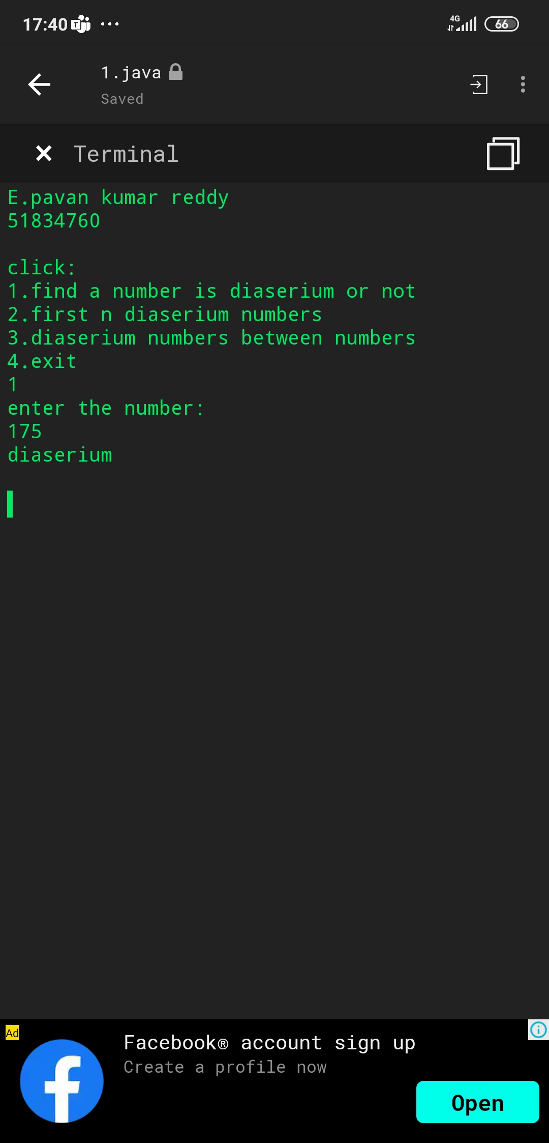

2)
import java.util.Arrays;

public class Main
{
public static void main(String[] args)
{
int arr[]={1,0,0,0,1,0,1,1,0,1};
int n=arr.length;

int zeroCount = 0;

System.out.println("E.pavan kumar reddy\n51834760\n");

for (int i = 0; i<n; i++)
{
//if array contains 0 count increases
//it is to found no.of zeroes
if (arr[i] == 0)
{
zeroCount++;
}
}

for (int i = 0; i < zeroCount; i++)
{
//from index 0 to zerocount the array replaces 0
arr[i] = 0;
}

for (int i = zeroCount; i < n; i++)
{
//remaining 1
arr[i] = 1;

}
System.out.println("output: "+Arrays.toString(arr));

}
}

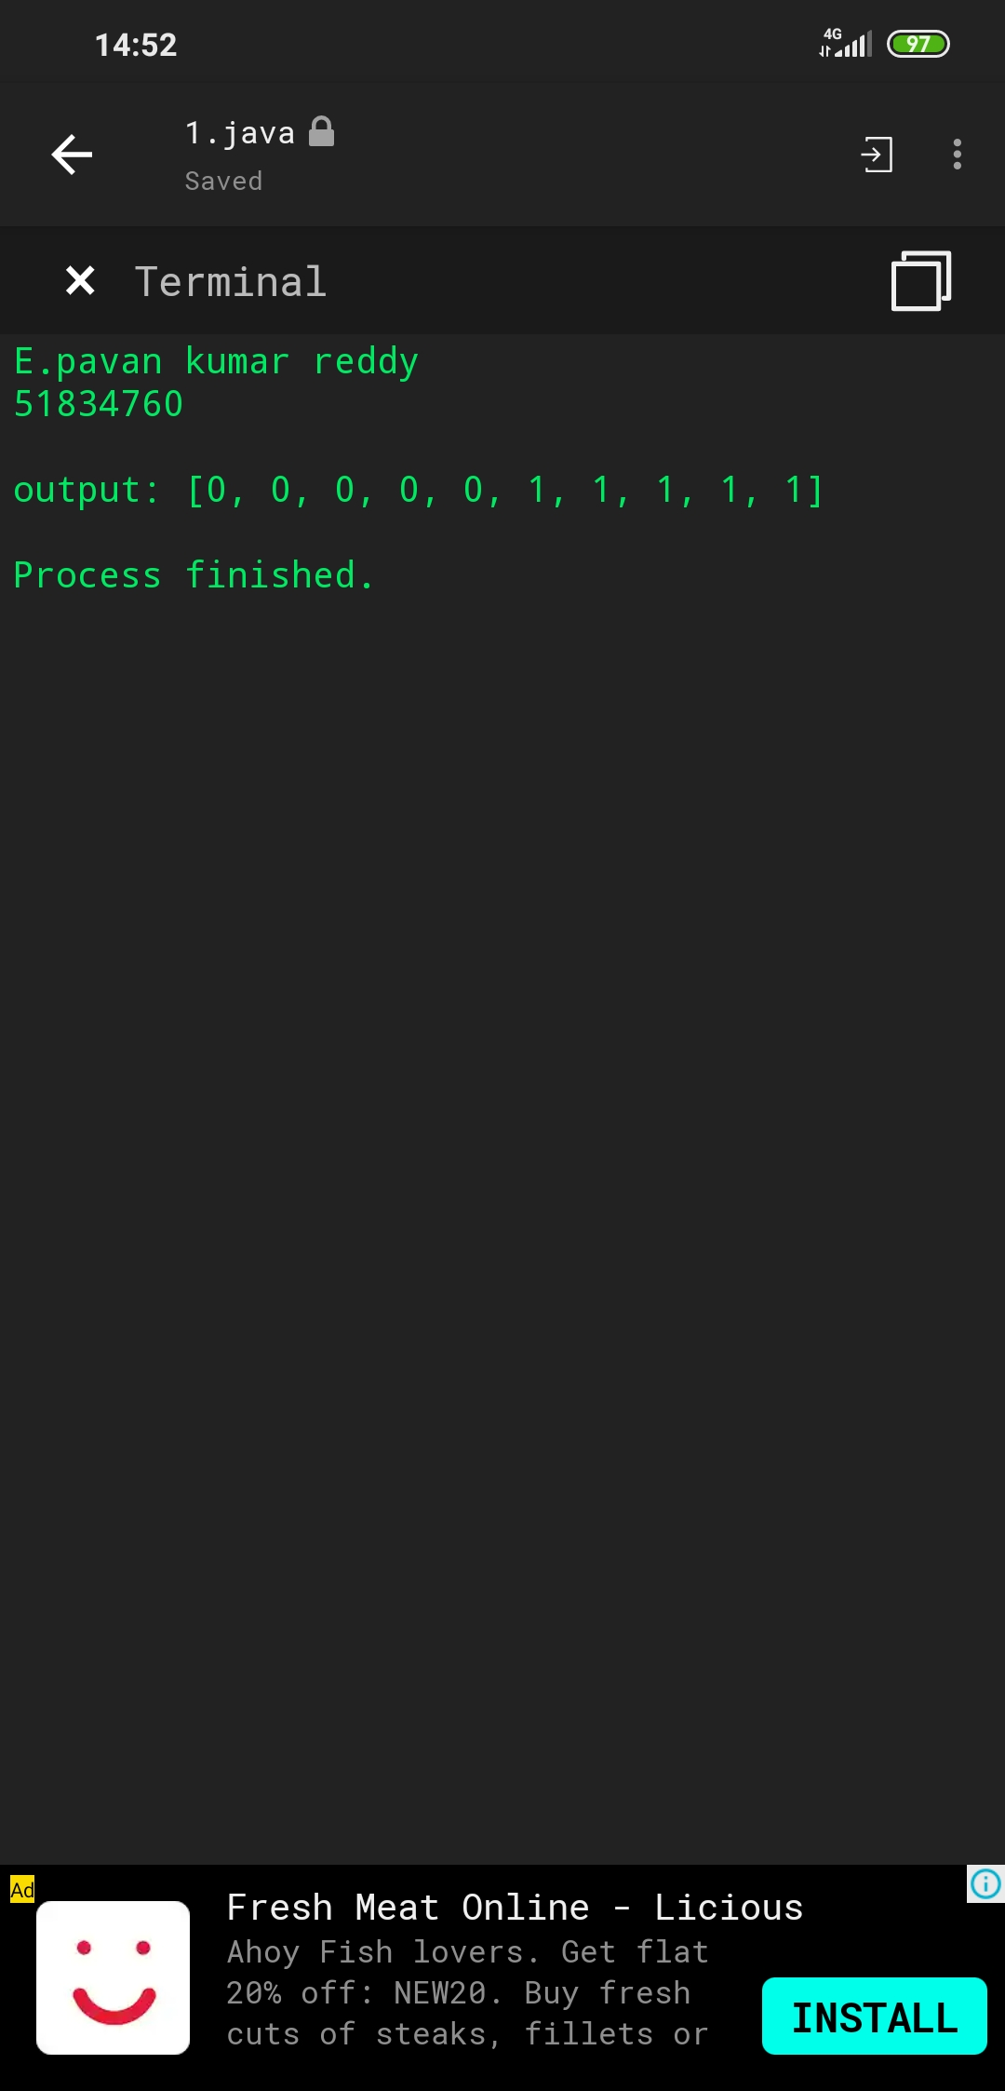

3)
import java.util.*;
class Pavan{
public static void main(String args[]){
Scanner sc=new Scanner(System.in);
System.out.println("e.pavan kumar reddy\n51834760");
System.out.println("input: ");
int num=sc.nextInt();

int tem=num;
int mun=0;
System.out.println("enter number to replace");
int a=sc.nextInt();
int rem=0;
System.out.println("enter number");
int b=sc.nextInt();
int count=0;
while(tem>0) {
tem=tem/10;
count=count+1;
}
while(num>0){
rem=num%10;
mun=mun*10+rem;
num=num/10;
}
System.out.println("output: ");
for(int i=0;i<count;i++){
rem=mun%10;
if(rem==a){
System.out.print(b);
}
else{
System.out.print(rem);
}
mun=mun/10;
}
}
}

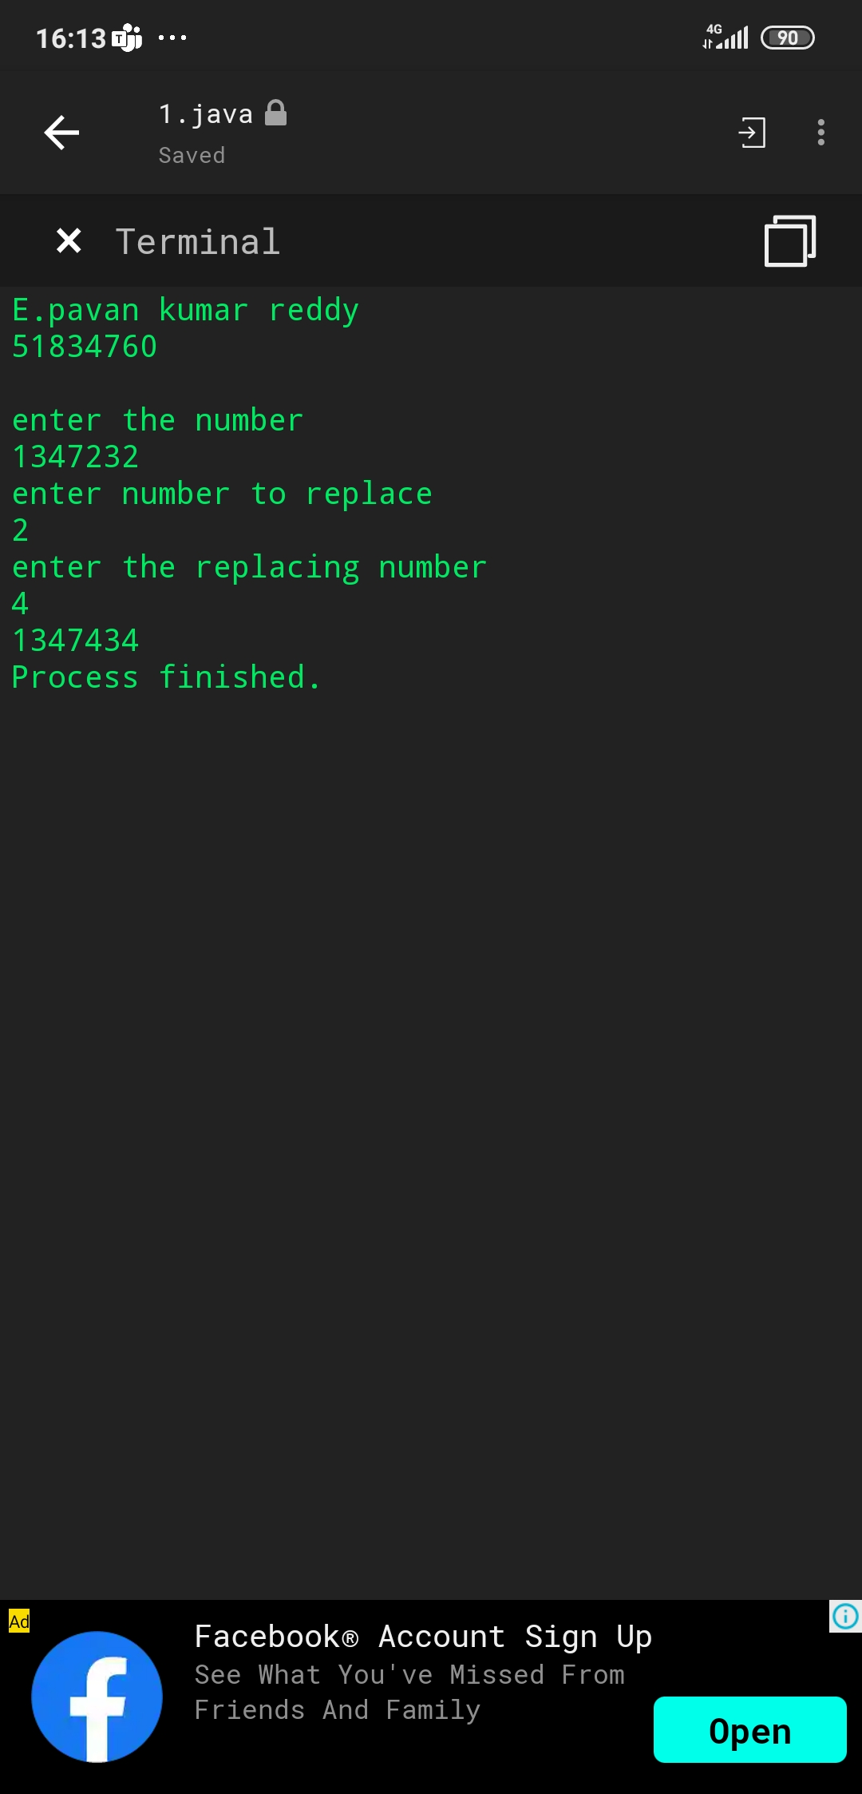

4)

5)
import java.util.*;
class Pavan{
static int search(String[] arr, String x)
{
int l = 0, r = arr.length - 1;
while (l <= r) {
int m = l + (r - l) / 2;

int res = x.compareTo(arr[m]);

// Check if x is present at mid
if (res == 0)
return m;

// If x greater, ignore left half
if (res > 0)
l = m + 1;

// If x is smaller, ignore right half
else
r = m - 1;
}

return -1;
}

// Driver method to test above
public static void main(String []args)
{
Scanner sc=new Scanner(System.in);
System.out.println("E.pavan kumar reddy\n51834760\n");
String[] arr = {"hello","everyone","good","bad"};
System.out.println("enter an element to search: ");
String x =sc.nextLine();
int result = search(arr, x);

if (result == -1)
System.out.println("element not present");
else
System.out.println(" the element is at index" + result);
}
}
